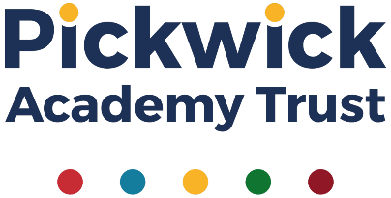

10 May 2021
Dear Parents and Carers,
RE: Optional Webinars for PAT Parents and Carers – Next webinar now released!
As part of Pickwick Academy Trust, we are all committed to working together to provide the best for our children. We have teamed up with Nicola Pearson, who runs ‘Minds of Wonder’, to provide a series of short webinars for our parents and carers.
The first two of these pre-recorded webinars, ‘Resilience for learning and Well-being’ and ‘Helping your child cope with anxiety’ have been received very positively. They have been viewed over 300 times so far and both remain available to all parents and carers in our PAT schools via the link. Our next webinar is now ready! This time the focus is on ‘Digital Parenting’ and available through this link. Nicola explores the benefits and challenges of technology for our children, how to manage screen time and what the research says in order to help us navigate digital parenting. The webinar lasts under 35 minutes and you can pause, stop and start it again to suit you.
This webinar will be followed by an optional live Zoom session with Nicola. This is designed to be an informal follow-up session, to give parents and carers a chance to share ideas, ask questions and meet others. If you have any questions you would like Nicola to talk about, please submit them ahead of the session by emailing booking@pickwickacademytrust.co.uk .
Please register attendance using the link below.
Saturday 22 May 10—10.30am Register in advance for this follow-up session:
https://us02web.zoom.us/meeting/register/tZwtcOmqpjsrHdanWaprgZRvxcrTEE2edPmy
After registering, you will receive a confirmation email containing information about joining the meeting.
We hope that you find the pre-recorded material useful and look forward to seeing some of you at the follow-up session on the 22 May.
With best wishes,
Amy Tapscott
Amy Tapscott
Professional Development Director
Pickwick Academy Trust
www.pickwickacademytrust.co.uk

